|  |  |  |  |  |  |  |  |  |  |  |
| --- | --- | --- | --- | --- | --- | --- | --- | --- | --- | --- |
| index: | 0 | 1 | 2 | 3 | 4 | 5 | 6 | 7 | 8 | 9 |
| x | 0 | 1 | 2 | 3 | 4 | 5 | 6 | 7 | 8 | 9 |
| y | 1 | 1 | 1 | -1 | -1 | -1 | 1 | 1 | 1 | -1 |
|  |  |  |  |  |  |  |  |  |  |  |
| W0 | 0.1 | 0.1 | 0.1 | 0.1 | 0.1 | 0.1 | 0.1 | 0.1 | 0.1 | 0.1 |
|  |  |  |  |  |  |  |  |  |  |  |
| Step 1 | x<2.5 | 2.5 |  |  |  |  |  |  |  |  |
| Incorrect? | 0 | 0 | 0 | 0 | 0 | 0 | 1 | 1 | 1 | 0 |
| err | 0.300 | 2.333 |  |  |  |  |  |  |  |  |
| a | 0.368 |  |  |  |  |  |  |  |  |  |
| pW1 | 0.100 | 0.100 | 0.100 | 0.100 | 0.100 | 0.100 | 0.144 | 0.144 | 0.144 | 0.100 |
| W1 | 0.088 | 0.088 | 0.088 | 0.088 | 0.088 | 0.088 | 0.127 | 0.127 | 0.127 | 0.088 |
|  |  |  |  |  |  |  |  |  |  |  |
| Step 2 | x<8.5 | 8.5 |  |  |  |  |  |  |  |  |
| Incorrect? | 0 | 0 | 0 | 1 | 1 | 1 | 0 | 0 | 0 | 0 |
| err | 0.265 | 2.778 |  |  |  |  |  |  |  |  |
| a | 0.444 |  |  |  |  |  |  |  |  |  |
| pW2 | 0.088 | 0.088 | 0.088 | 0.138 | 0.138 | 0.138 | 0.127 | 0.127 | 0.127 | 0.088 |
| W2 | 0.077 | 0.077 | 0.077 | 0.120 | 0.120 | 0.120 | 0.111 | 0.111 | 0.111 | 0.077 |
|  |  |  |  |  |  |  |  |  |  |  |
| Step 2 | x>5.5 | 5.5 |  |  |  |  |  |  |  |  |
| Incorrect? | 1 | 1 | 1 | 0 | 0 | 0 | 0 | 0 | 0 | 1 |
| err | 0.307 | 2.253 | 0.693 |  |  |  |  |  |  |  |
| a | 0.353 |  |  |  |  |  |  |  |  |  |
| pW3 | 0.109 | 0.109 | 0.109 | 0.120 | 0.120 | 0.120 | 0.111 | 0.111 | 0.111 | 0.109 |
| W3 | 0.097 | 0.097 | 0.097 | 0.106 | 0.106 | 0.106 | 0.098 | 0.098 | 0.098 | 0.097 |
|  |  |  |  |  |  |  |  |  |  |  |
|  |  |  |  |  |  |  |  |  |  |  |
|  | 0.3680 | 0.3680 | 0.3680 | 0.0000 | 0.0000 | 0.0000 | 0.0000 | 0.0000 | 0.0000 | 0.0000 |
|  | 0.4438 | 0.4438 | 0.4438 | 0.4438 | 0.4438 | 0.4438 | 0.4438 | 0.4438 | 0.4438 | 0.0000 |
|  | 0.0000 | 0.0000 | 0.0000 | 0.0000 | 0.0000 | 0.0000 | 0.3527 | 0.3527 | 0.3527 | 0.3527 |
|  |  |  |  |  |  |  |  |  |  |  |
|  | 0.8117 | 0.8117 | 0.8117 | 0.4438 | 0.4438 | 0.4438 | 0.7964 | 0.7964 | 0.7964 | 0.3527 |
|  |  |  |  |  |  |  |  |  |  |  |
|  | 1 | 1 | 1 | 0 | 0 | 0 | 1 | 1 | 1 | 0 |
|  | 1 | 1 | 1 | -1 | -1 | -1 | 1 | 1 | 1 | -1 |
|  | TRUE | TRUE | TRUE | TRUE | TRUE | TRUE | TRUE | TRUE | TRUE | TRUE |

> #problem 2

> library(plot3D)

> data = read.table(file="/Users/eotles/Downloads/PCA Service.csv",sep=",");

> cleanData = data[,2:11]

>

> pc = princomp(cleanData, cor=FALSE, center=TRUE, scale=TRUE)

> pc$loading

Loadings:

Comp.1 Comp.2 Comp.3 Comp.4 Comp.5 Comp.6 Comp.7 Comp.8 Comp.9 Comp.10

V2 -0.424 0.905

V3 0.999

V4 -0.996

V5 -0.901 -0.423

V6 -0.982 0.180

V7 0.117 -0.266 -0.184 -0.936

V8 -0.129 0.952 -0.277

V9 -0.216 0.828 -0.506

V10 -0.963 -0.268

V11 -0.154 0.478 0.850 0.136

Comp.1 Comp.2 Comp.3 Comp.4 Comp.5 Comp.6 Comp.7 Comp.8 Comp.9 Comp.10

SS loadings 1.0 1.0 1.0 1.0 1.0 1.0 1.0 1.0 1.0 1.0

Proportion Var 0.1 0.1 0.1 0.1 0.1 0.1 0.1 0.1 0.1 0.1

Cumulative Var 0.1 0.2 0.3 0.4 0.5 0.6 0.7 0.8 0.9 1.0

> pc$scores

Comp.1 Comp.2 Comp.3 Comp.4 Comp.5 Comp.6 Comp.7 Comp.8 Comp.9 Comp.10

[1,] 32899.222 -108983.817 50564.428 -145.86342 -6.0321050 6.1868250 -3.66388194 1.40990687 -2.41812141 -0.40909810

[2,] 21225.539 -72754.286 -5521.327 1001.58825 4.1566626 -4.1132154 0.07043531 -1.28678485 5.14795024 -0.96337532

[3,] 48923.784 5696.187 18351.194 221.65372 40.6696816 1.8509683 8.03330999 -0.20583644 0.01400411 0.34023671

[4,] -301725.600 -4322.373 5724.944 -130.35907 -25.0271375 5.1635592 -6.04386018 -2.93791598 1.82776790 0.27131919

[5,] 75382.208 20316.223 15432.776 -229.05705 33.5041051 -14.7512160 -2.75491774 -3.69353252 -0.34854420 0.07067969

[6,] -204605.071 26212.312 14616.237 145.64733 -34.7673899 -9.0230599 7.42411725 -0.45024246 0.08986003 0.47278613

[7,] 64542.199 12510.253 9845.799 -270.61612 13.5455808 -3.8756861 2.24546320 -0.78682011 0.29616099 1.43296640

[8,] -81759.418 -37644.170 -15307.782 -26.74775 2.6964557 -3.9965096 -1.04993256 2.28003361 1.48483368 1.12184245

[9,] 28730.843 -37888.668 -14565.891 -334.29875 7.2780914 -10.0303845 -0.60093629 1.39996290 0.74833513 -0.47338371

[10,] -306553.961 1949.018 -2247.353 -158.73064 0.9907543 -1.7755680 9.26334474 -0.89632467 -0.49218630 -1.36071552

[11,] 73830.368 12867.896 7034.582 -73.65591 -37.1424985 1.3808438 1.94925749 -0.57711898 0.70020400 2.19768083

[12,] 82360.019 19111.633 8741.682 -170.83740 -19.8397996 -5.1288202 11.04597844 -1.47304893 -0.08688129 -0.15173210

[13,] 40794.108 -34453.542 -18715.741 -1226.50318 13.2685087 -8.9323467 1.56522890 1.71216180 -0.06665505 -0.24743026

[14,] 73944.522 -14173.363 -9617.708 -670.78975 -36.9840033 21.3828951 5.93326158 0.29960465 0.35772056 -0.03859762

[15,] 42741.137 -14863.026 -11278.455 759.64978 17.0334306 3.9068726 1.34444370 -2.03768928 -0.43965274 0.58276987

[16,] 45381.009 -31615.040 -19968.300 -653.15557 7.0065864 4.9018975 -3.78941096 1.61766836 -0.18019485 0.50619838

[17,] 83199.423 20749.094 4335.543 -292.35110 -34.7570355 -22.0844830 -8.69073550 -4.38670728 0.31082716 -1.01539963

[18,] -180015.082 -7451.829 -11938.008 96.72983 22.8668450 0.3312368 1.47383182 0.14553239 -1.90590139 0.06283535

[19,] 47938.119 -20500.631 -16846.267 1009.81741 -7.4790773 -1.1272224 0.28691850 -2.64759080 -2.49003458 0.05036978

[20,] -19334.448 27907.210 4534.176 157.55240 8.9556462 -2.1192933 3.08899037 9.77518583 0.24358118 -0.88158125

[21,] 19360.472 26970.843 4090.531 30.52998 23.9289033 -0.1879204 -1.30924345 2.19536960 0.81751105 0.80702110

[22,] 80628.021 26537.347 3999.834 -182.88934 32.8640889 8.7172196 -0.75175263 -2.91618907 1.57564986 1.30573532

[23,] 67750.100 22452.357 1312.974 300.49918 -13.1328011 1.3428194 -5.83818327 4.53156963 0.46056235 -0.14303781

[24,] -6959.147 29560.480 3791.164 69.40534 50.5530863 -3.3606278 0.37587999 0.64534450 0.06748770 -0.70994557

[25,] -33895.962 2388.861 -10105.843 55.39991 -16.6896646 -5.3157304 -3.10338642 0.02580035 -1.72849794 2.99408979

[26,] -173408.754 34612.931 3402.452 -85.10099 21.3255453 13.2936611 -14.01058419 -0.18895400 -0.81863603 -0.51894168

[27,] 73561.385 29410.734 3322.037 516.77365 -21.3921424 10.8694945 -1.44603750 2.58723251 0.48065996 1.02429309

[28,] 59781.932 -10950.756 -17276.442 359.48058 0.3280593 1.8734789 1.39630686 -2.45716583 -4.01994379 -0.67029916

[29,] 83383.457 22385.435 -2830.483 -155.95561 -2.6091660 12.8210365 1.60301225 -2.85775407 0.26847005 -2.41104406

[30,] 85590.952 26515.283 -1129.316 -218.54449 -9.7200188 11.0076663 -0.50120139 -3.31573090 1.07560484 -1.43262240

[31,] 76308.622 27447.402 -1751.438 300.72878 -35.3991921 -9.2083908 -3.54571638 4.49003316 -0.97194121 -1.81361990

> plot(pc)

>

> mat_2 = pc$loading[,1:2]

> t(mat_2) %*% mat_2

Comp.1 Comp.2

Comp.1 1.000000e+00 6.252919e-17

Comp.2 6.252919e-17 1.000000e+00

> plot(pc$scores[,1],pc$scores[,2])

>

> scatter3D(pc$scores[,1],pc$scores[,2],pc$scores[,3])

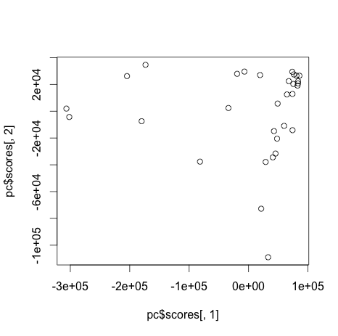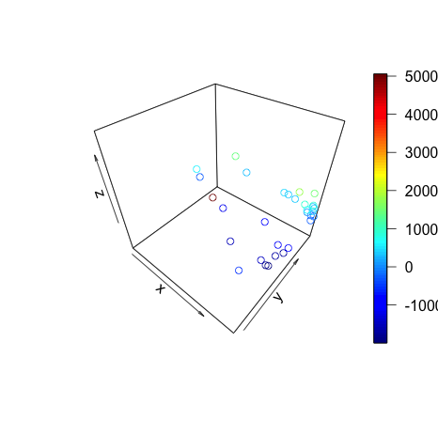

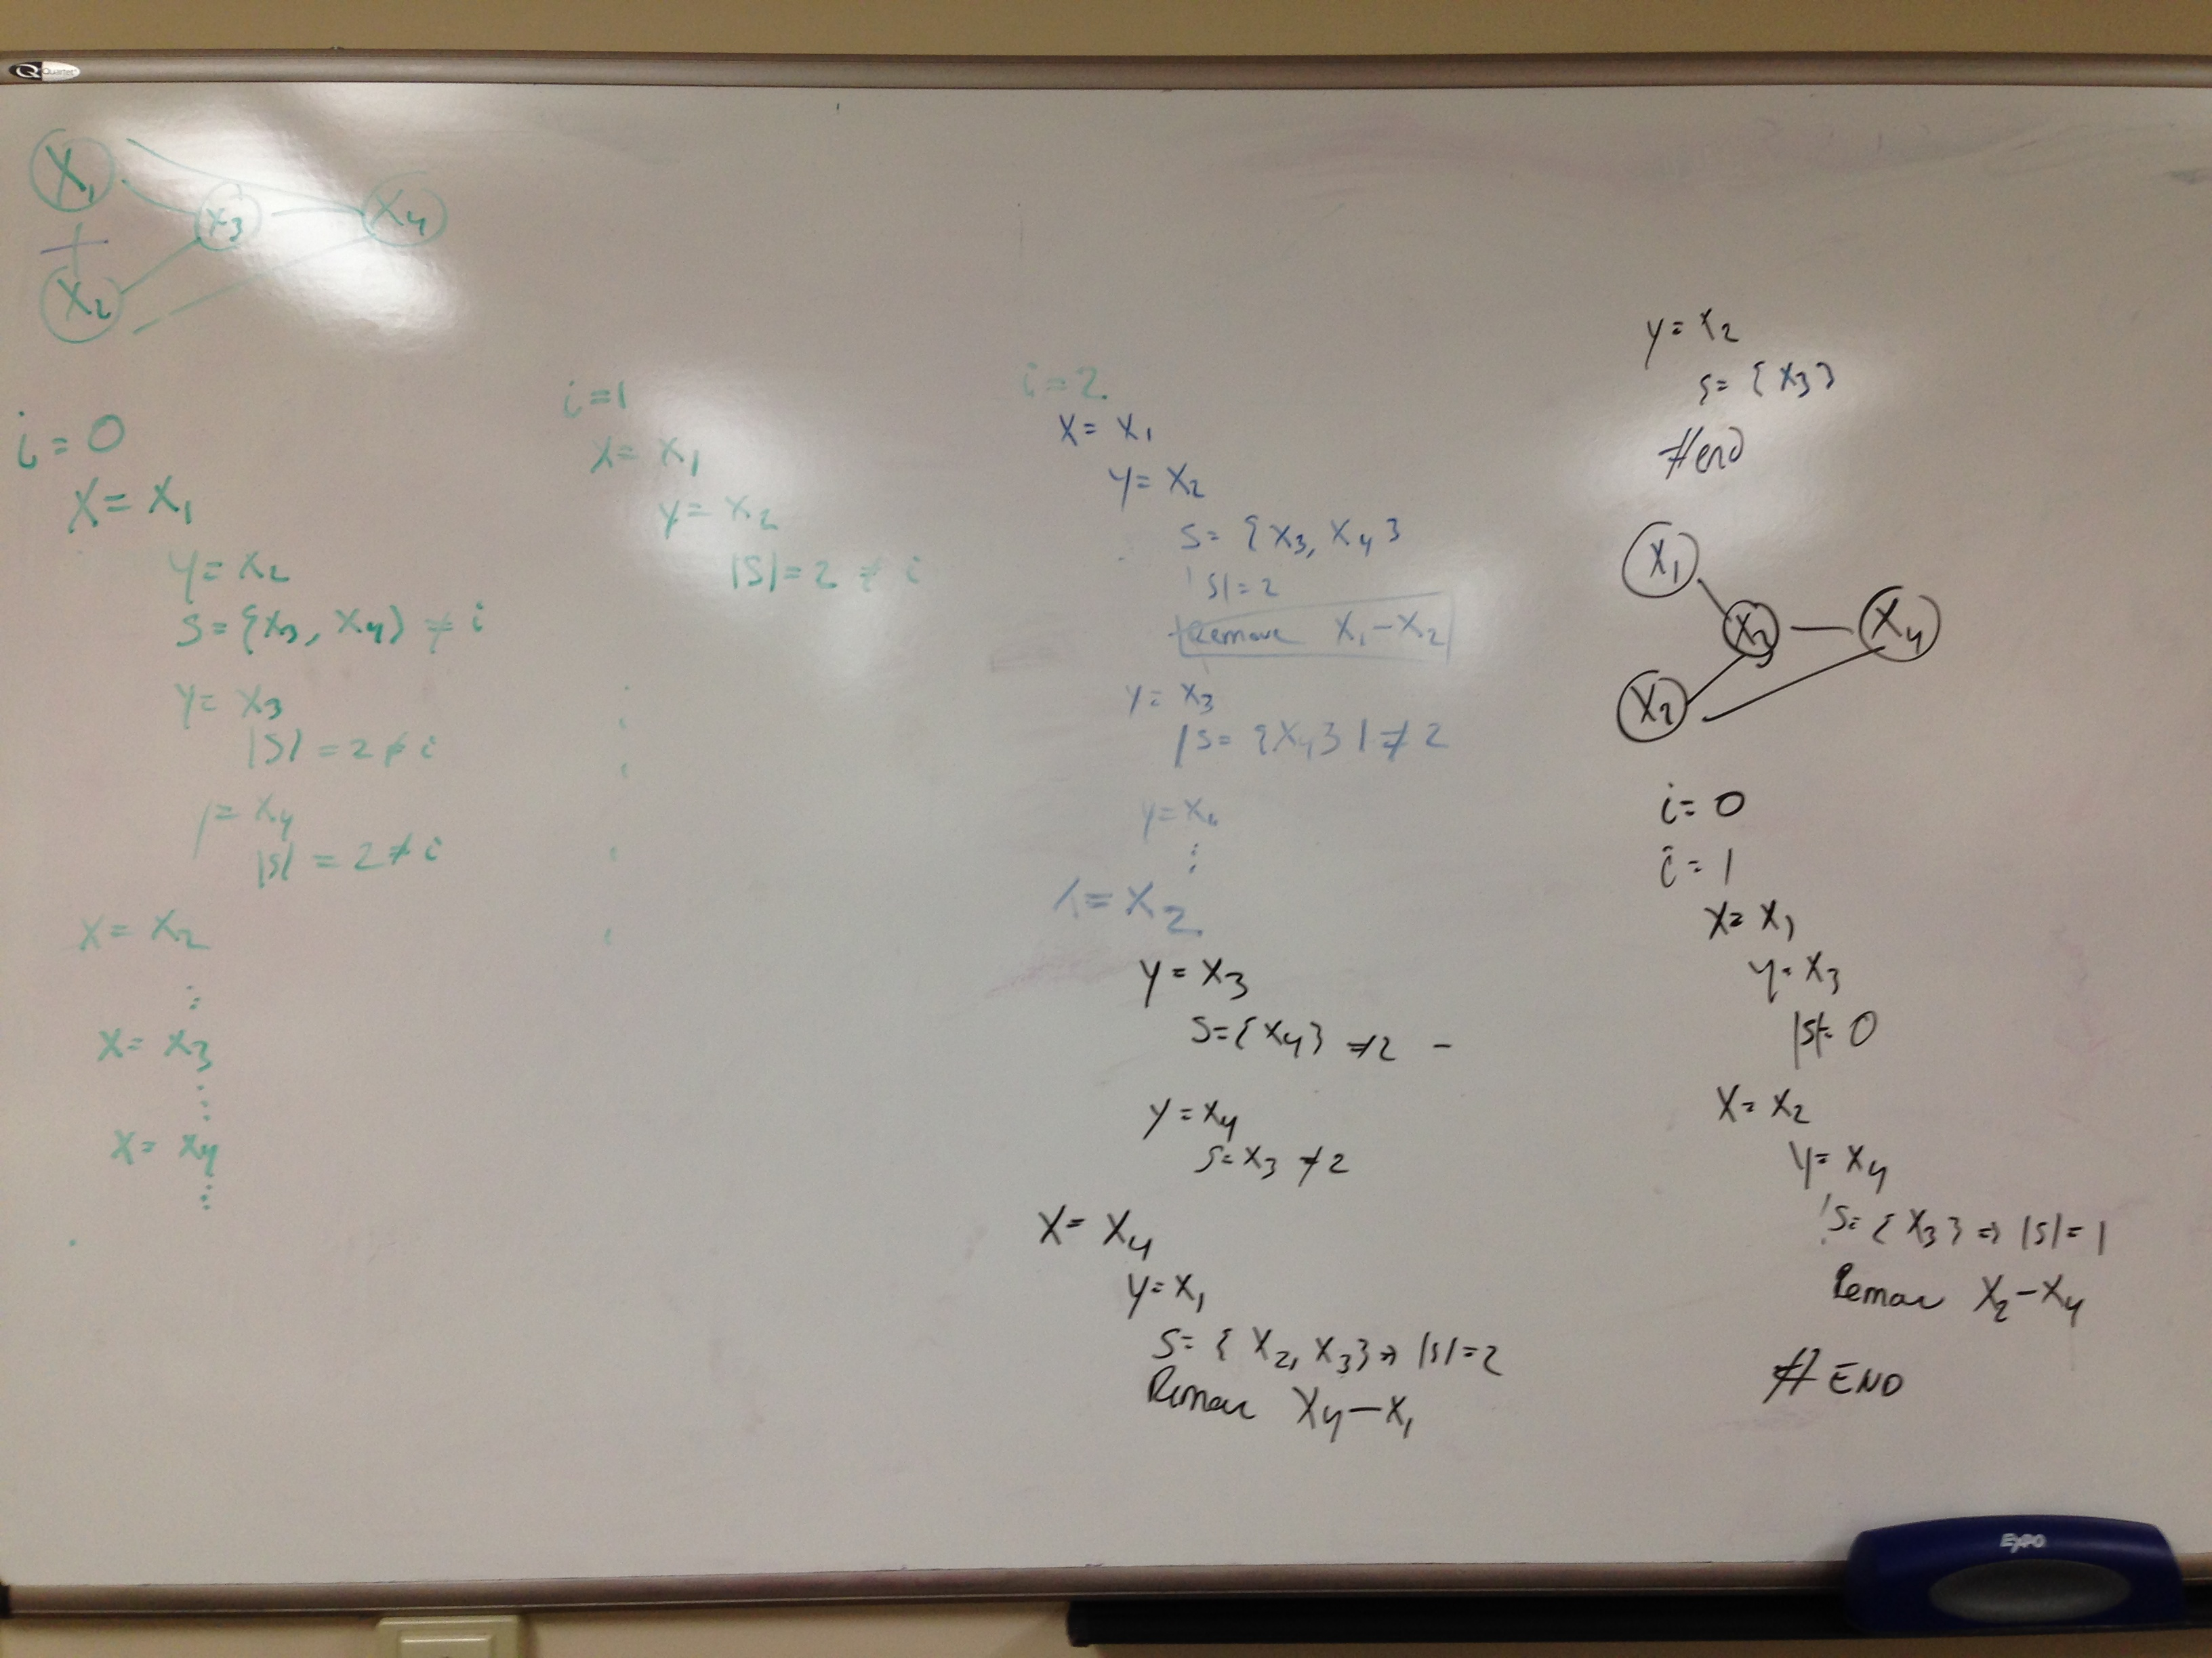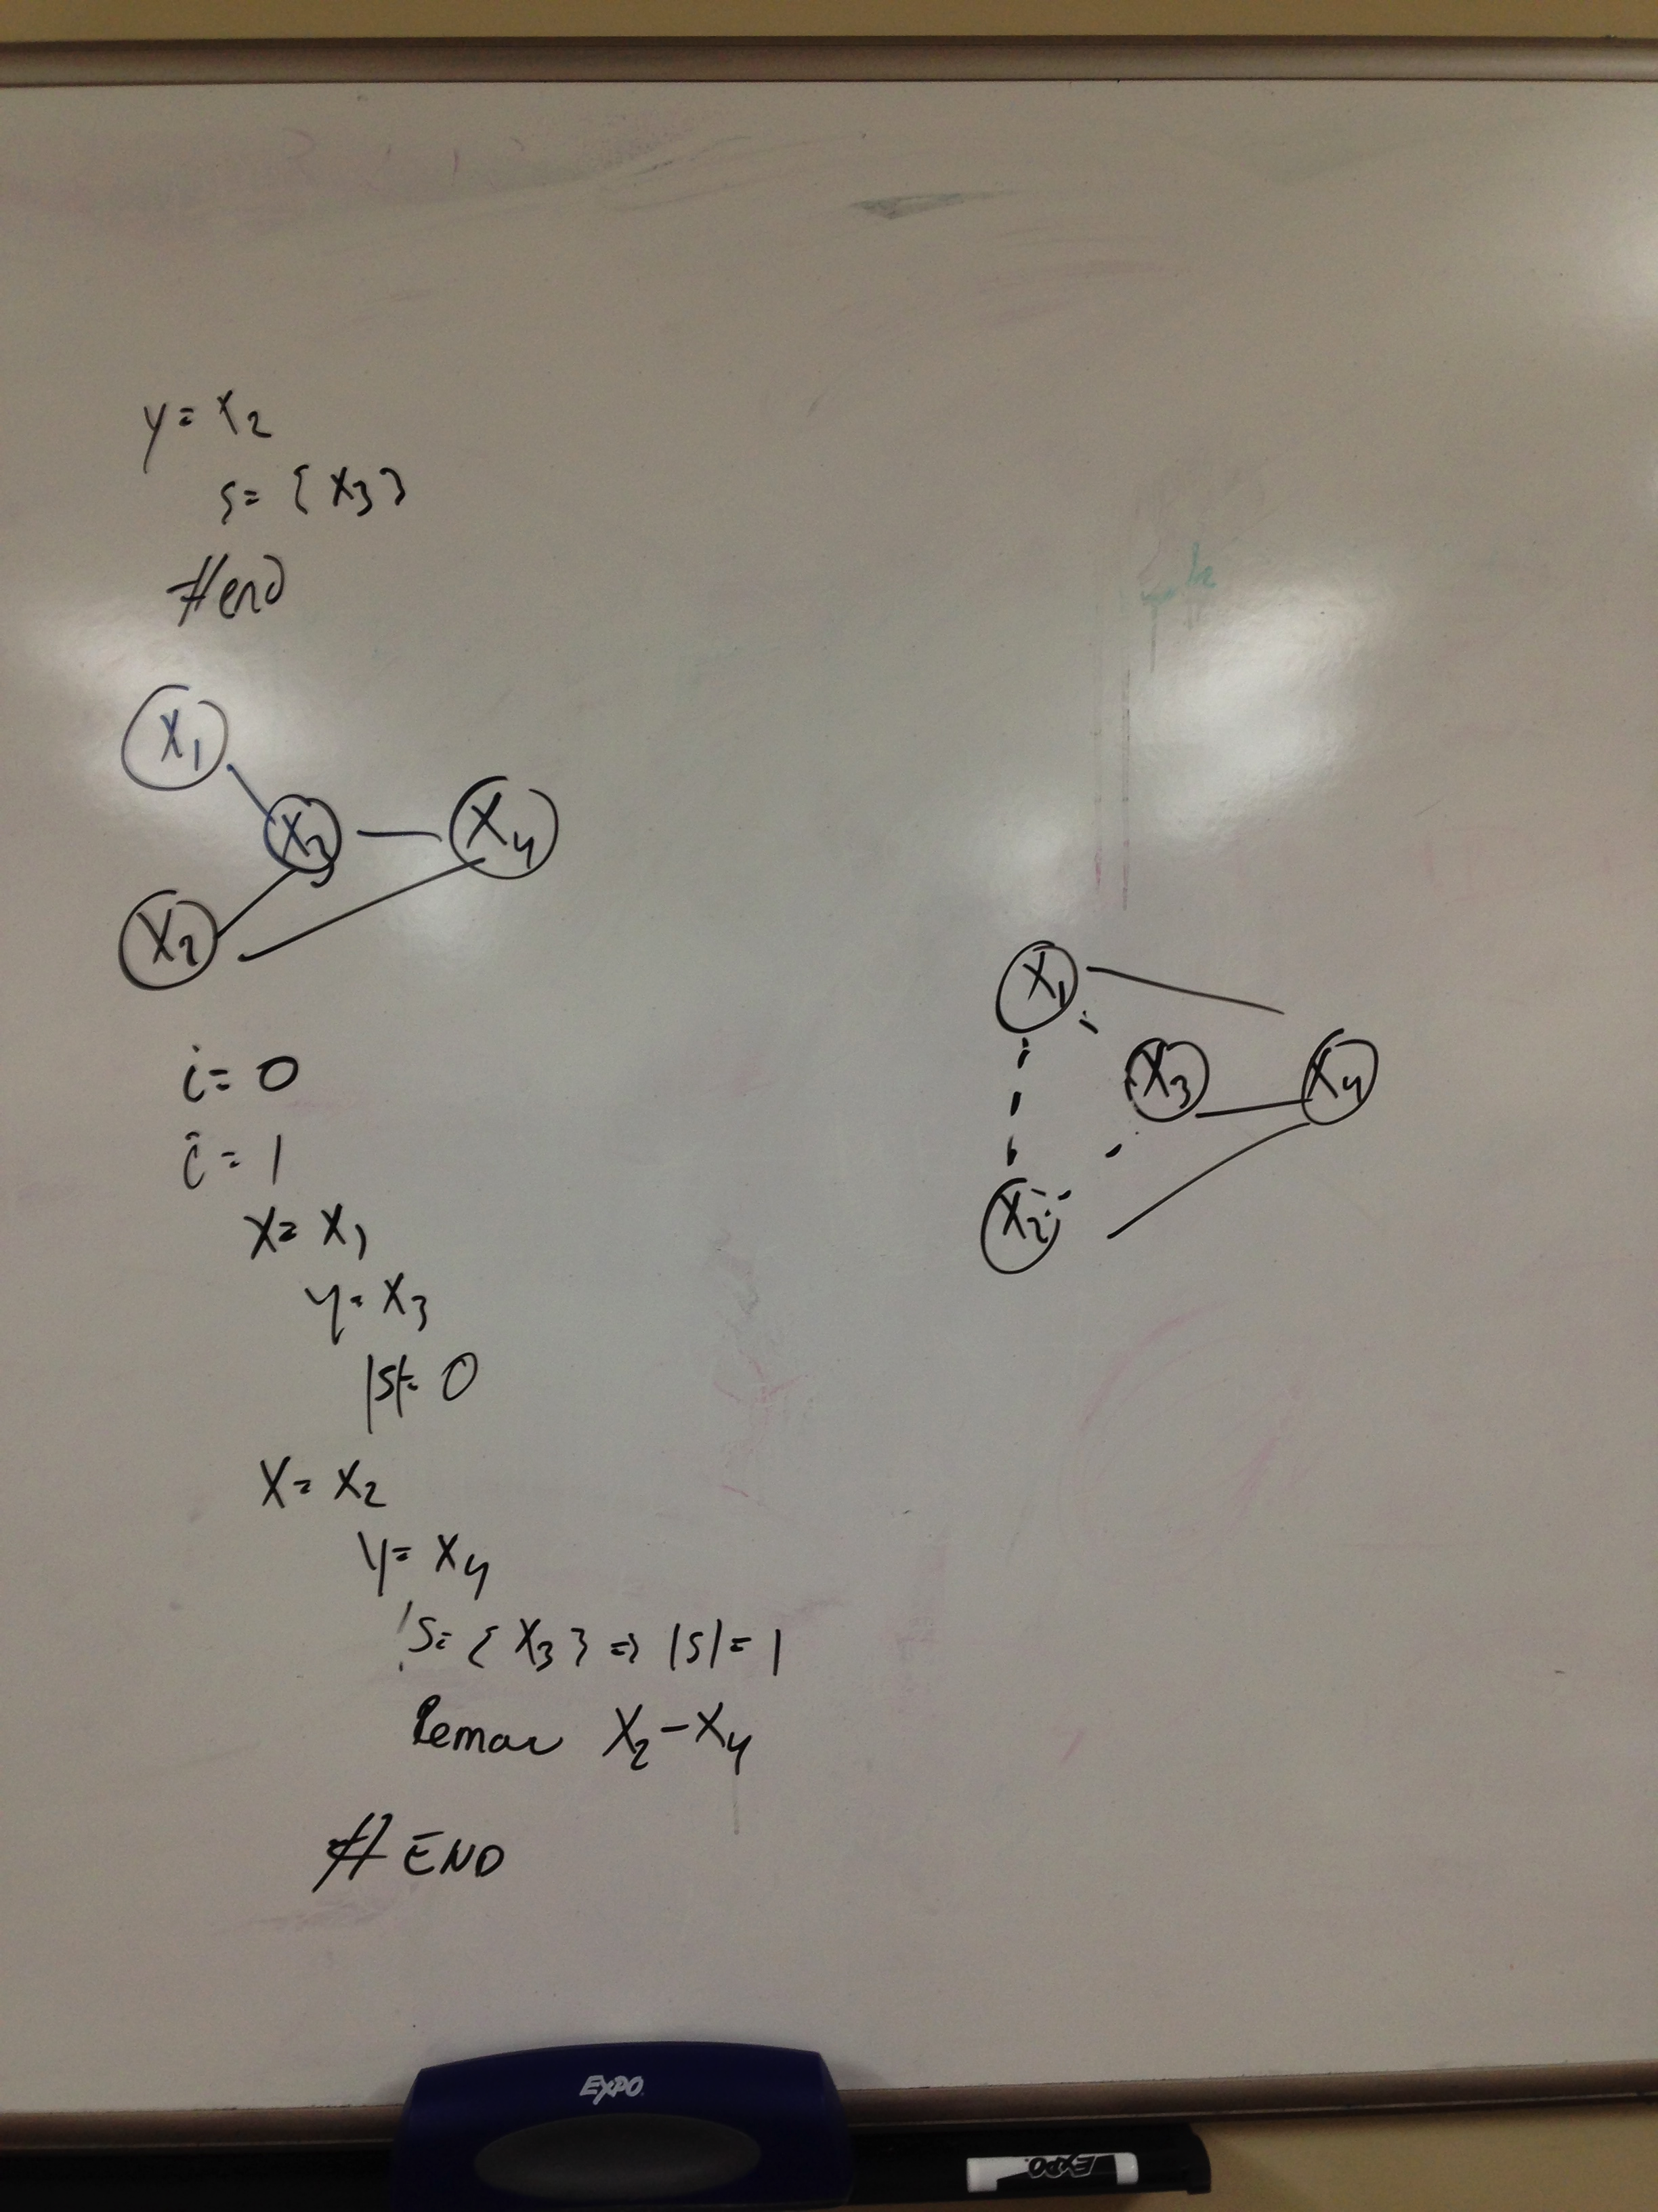

%code based on Dr. Liu’s classnotes. Simply added a sample size loop.

N = 4;

dag = zeros(N,N);

C = 1; S = 2; R = 3; W = 4;

dag(C,[R S]) = 1;

dag(R,W) = 1;

dag(S,W)=1;

figure %draw the BN graph

draw_graph(dag, {'cloudy','Rain','Sprinkler','WetGrass'});

false = 1; true = 2;

ns = 2*ones(1,N); %% ns represent node_sizes, the number of values of nodes can take on

bnet = mk_bnet(dag, ns); %% Make a Bayesian network, makes a graphical model with an arc from i to j iff DAG(i,j) = 1.

bnet.CPD{C} = tabular_CPD(bnet, C, [0.5 0.5]); %% set parameters

bnet.CPD{R} = tabular_CPD(bnet, R, [0.8 0.2 0.2 0.8]);

bnet.CPD{S} = tabular_CPD(bnet, S, [0.5 0.9 0.5 0.1]);

bnet.CPD{W} = tabular_CPD(bnet, W, [1 0.1 0.1 0.01 0 0.9 0.9 0.99]);

sampleSize = [5,10,15,25,50,75,100,500,1000]

for ncases = sampleSize

data = zeros(N, ncases);

for m=1:ncases

data(:,m) = cell2num(sample_bnet(bnet)); %%sample_bnet returns a Nx1 cell array, data(i,j) contains the value of i node in case j

end

%% K2

%load data.mat; % load data or use the data we simulate

C = 1; S = 2; R = 3; W = 4;

order = [C S R W]; % specify an order for the nodes

nnodes=size(data,1);

ns = 2*ones(1,nnodes); %specify the number of values for each node

max_fan_in = 2; %specify the maximum number of parents for each node

dag2 = learn_struct_K2(data, ns, order, 'max_fan_in', max_fan_in) %k2 learning

figure %draw learned BN graph

draw_graph(dag2, {'cloudy','Rain','Sprinkler','WetGrass'});

title(strcat('K2 Alogrithm ',num2str(ncases)))

end

